**ShopNest Store Capstone Dashboard**

1. **Top Category by Total Price: -**

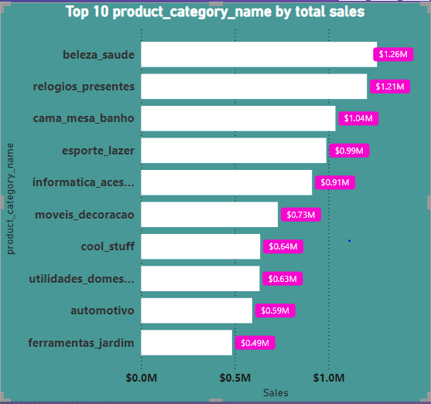

**Analysis**:- As pe the data analyzed in the power bi it shows that the top 10 product category name as per sales are reflected in the charts. In which the highest selling product category is “Beleza_saude” with the sales of $1.26M.

1. **Delayed order analysis: -**

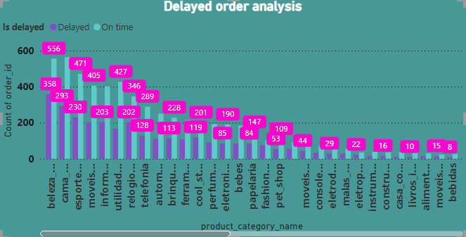

**Analysis**:- In this charts I have analyzed the delayed and on-time orders on the basis of product category name, this shows that the “Beleza-saude” has the highest number of On-time as well as delayed orders. However, the overall ratio of on-time delivered orders are higher than the delayed orders.

1. **Monthly comparison of Delayed & on-time orders: -**

**Analysis:-** This chart shows how the delayed and on-time orders are increasing monthly. As you can see the data there are No delayed orders in the month of January but then they are rapidly increasing as reaching out to the December.

1. **Payment method analysis: -**

**Analysis:-** This Chart shows the analysis of payment method used while making the order, Like as you can see credit card is the payment method which is mostly used while making the payment. Approximately 74% of the orders chooses credit card as a payment method.

1. **Product rating analysis: -**

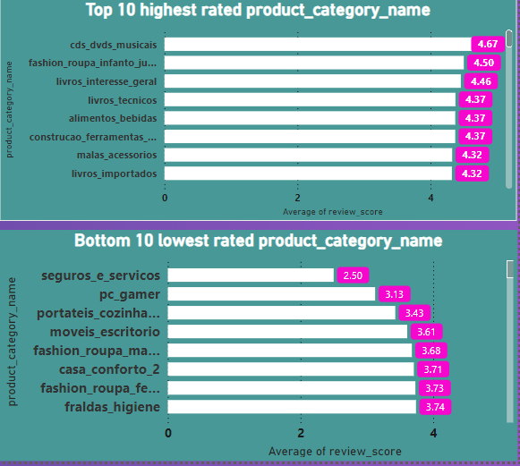

**Analysis:-** This chart shows the Highest and lowest rated products, in this chart I have considered the average rating for every product to analyze the Top 10 and bottom 10 products as per ratings. As conclusion the highest rated product category is “cds_dvds_musicais” with average of 4.67 and lowest is Seguros_e_servicos with 2.50.

1. **State-wise sales analysis: -**

**Analysis:-** This chart shows the State/city wise sales as you can see the data table the highest sales is in “Sao paulo” city and state is SP. As per the data the total sales is $16.01M

1. **Seasonal sales pattern: -**

**Analysis:-** As per the charts the sales in 2016 is high in the Q3, and in year 2017 and 2018 the sales are high in Q1. So we can say that sales are high in Q1 as compared to the other Quarters. So we can say that there can be some special offers or customer wants to spent more on occasions like new year or year start.

1. **Seasonal sales pattern: -**

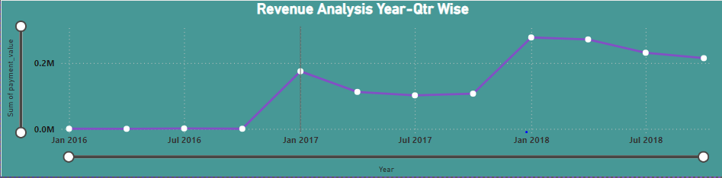

**Analysis:-** As per the charts the sales is increasing as per the year, As you can see the data the sales has been increased in 2017 and 2018 as compared to 2016. We can also say that as the year passing by the sales and revenue of the store is increasing.